SNM941 Installation and Configuration
SNM941 Overview
- Operating Voltage: 7 V DC to 32 V DC
- Configured via web browser interface
- Weatherproof
- Contains Cellular modem, Wifi Capability, and GNSS Receiver
- SIM card must be installed by installer
- Required equipment for subscription licensing
- Some units produced during Covid are not equipped with GNSS or Wifi
Default Wifi Password: SNM941-Serial Number or abcdeabcde
SNM941 Web Interface IP Addresses: 192.168.33.1 and 192.168.88.3
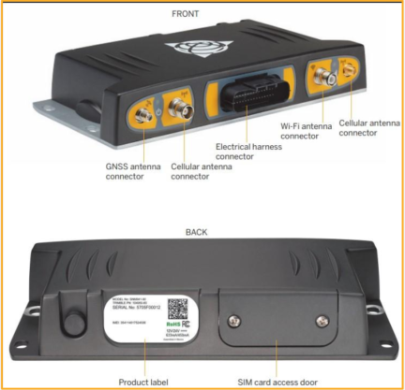
SNM941 Antenna
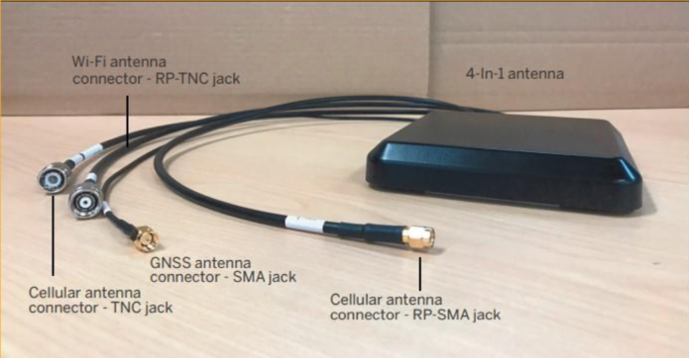
SNM941 Mounting
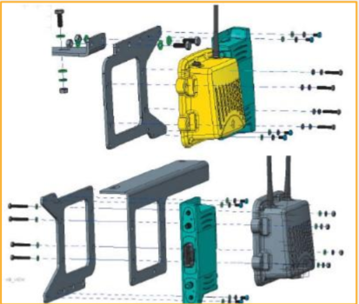
The SNM941 can be installed in various locations; however the recommended location is near the cab roof-line, typically with the SNR radio. to allow for:
- Ease of access
- A minimal distance from the antenna
- SIM card access
The SNM941 mounting is designed to be mounted concurrently with the SNR radio and to allow adequate space for attachment of the electrical harness, as well as the coaxial antenna connections.
Accessing SNM941 WebUI
